**Lecture 14**

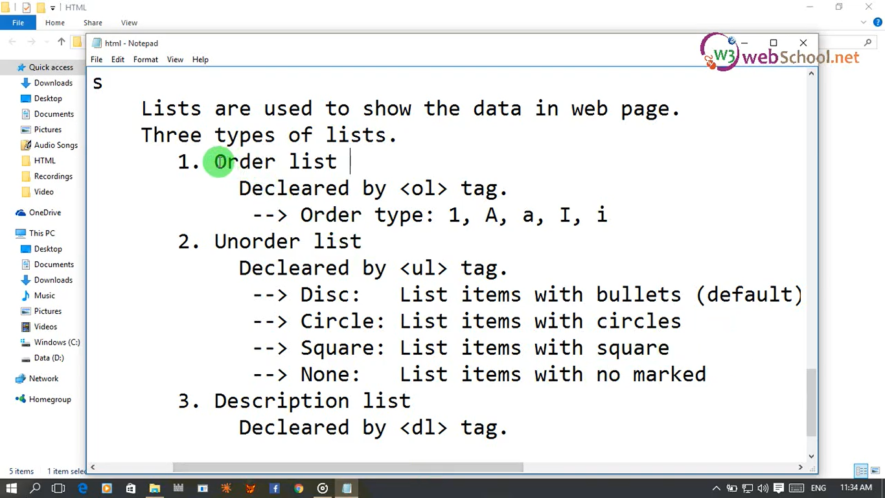

**Order List**